Programming Concepts  
Week 7 **Pass** Submission Tasks Template

Student ID: _____103055993________________

Student Name: ________Mario Stavreski______________________

## Pass Task 7 HTML code

Paste the HTML code of the web page here.

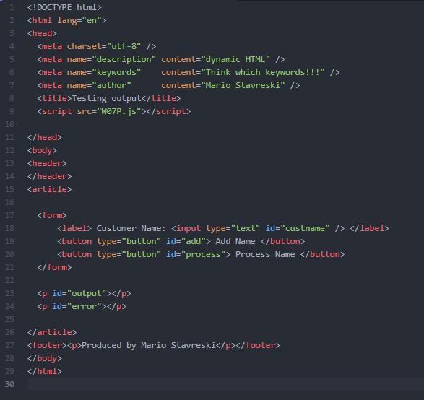

## Pass Task 7 JavaScript code

Paste the JavaScript code of the same page here.

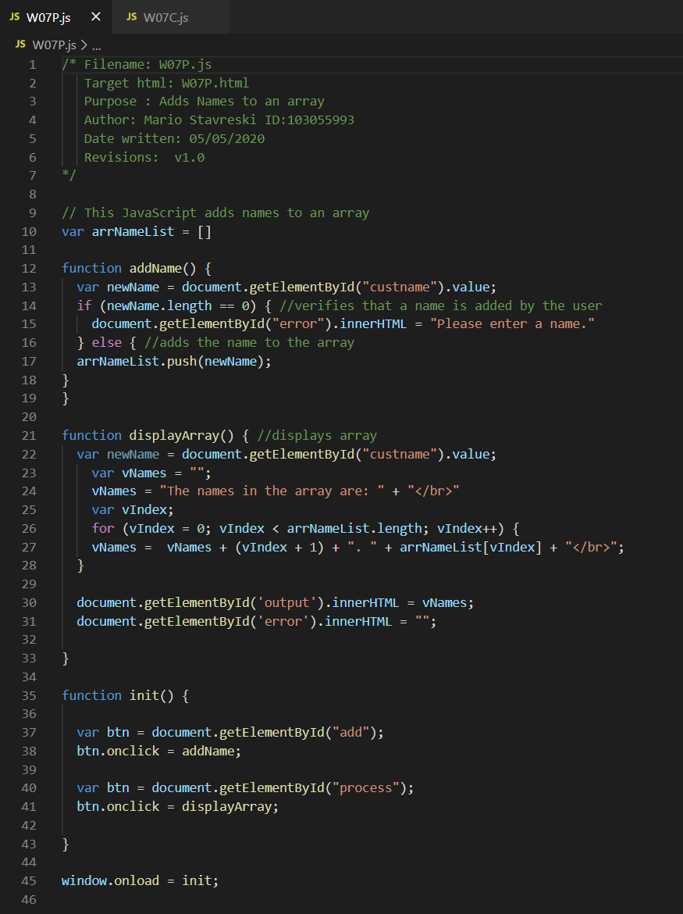

## Pass Task 7 web page testing

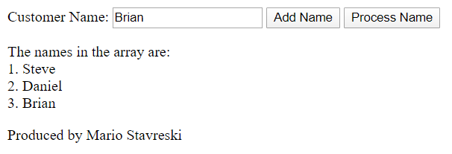

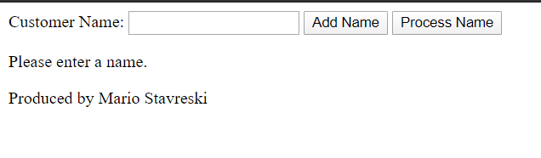

Paste the screen captures of your testing web page here.